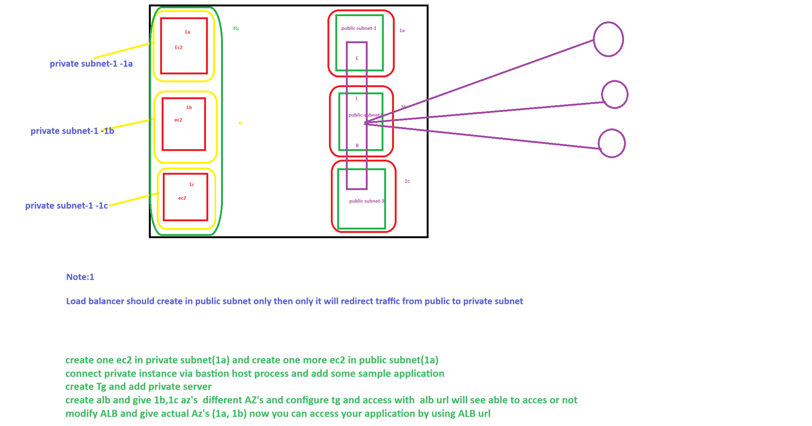

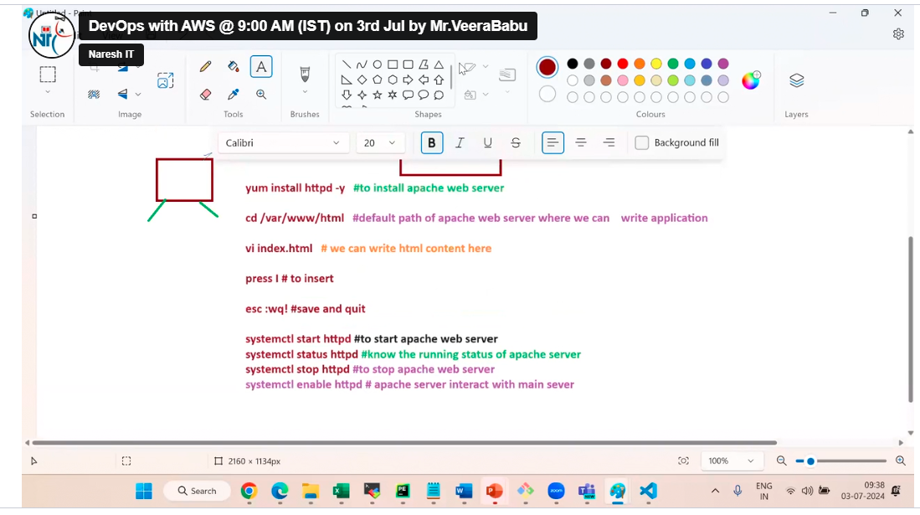

SSH to connect the server from external

HTTP is to access the application from external

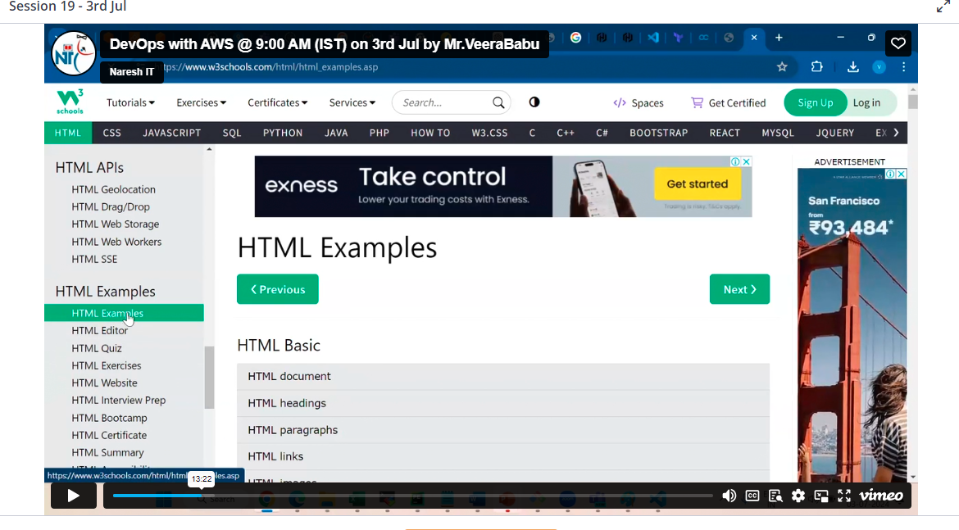

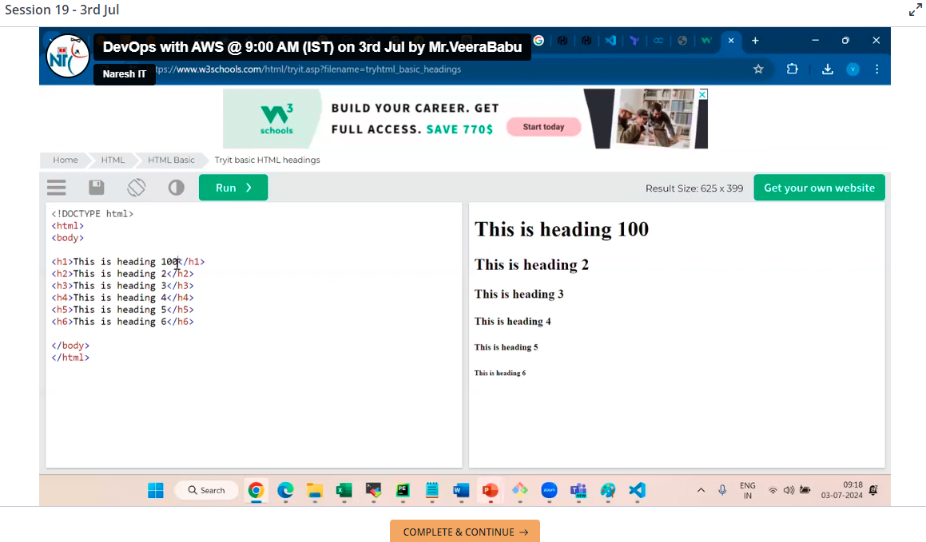

we have to install one web apache server which is front end and in this web server only we need to write content (for example here HTML content)

SSH and HTTP protocol must be added in SG in bound rule

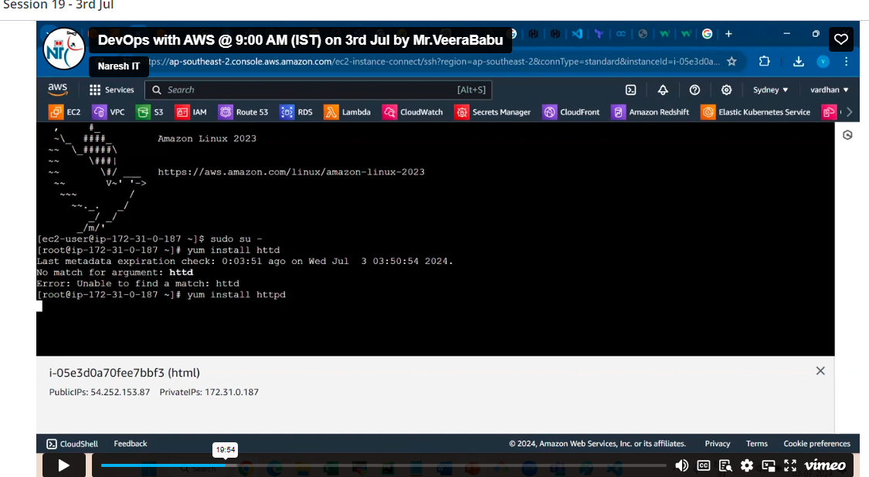

We are in EC2 server

Sudo su –

Yum install httpd -y to install apache web server

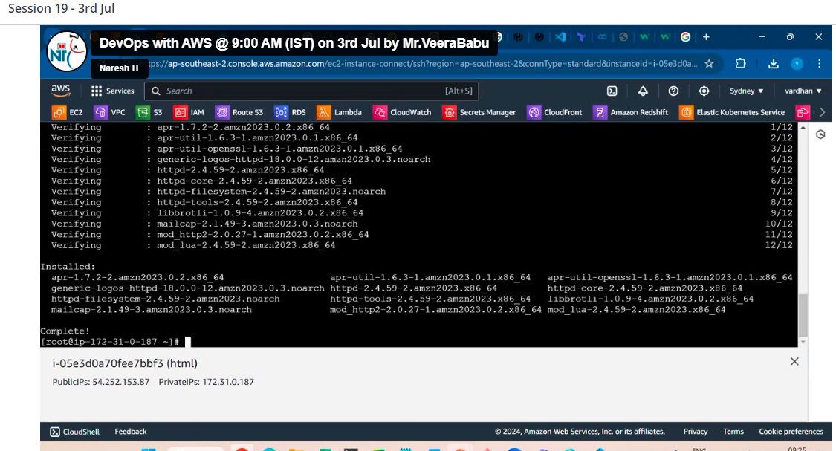

Cd /var/www/html default path of apache web server where we can write the application

Vi index.html default file for html, here we can write html content

Press I to insert

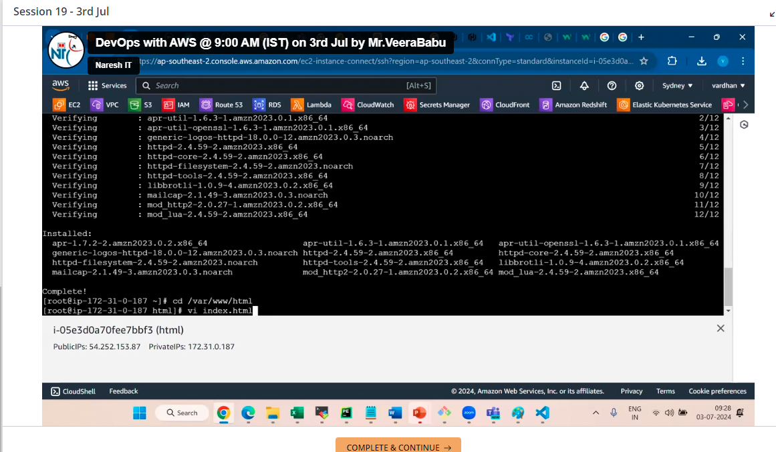

We can write anything.

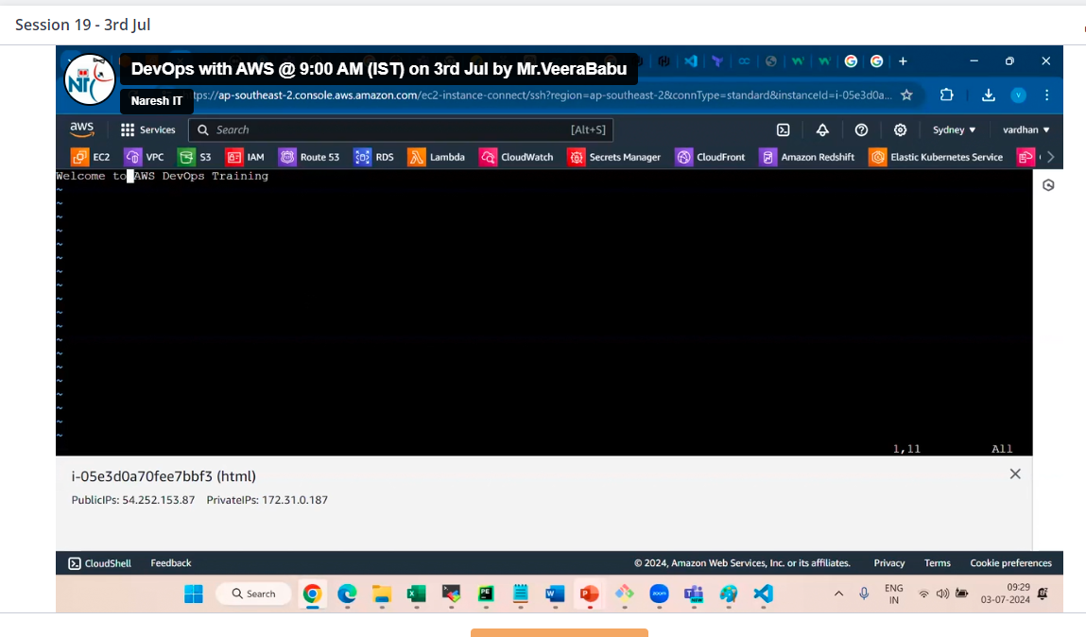

Press escape

:wq! save the file

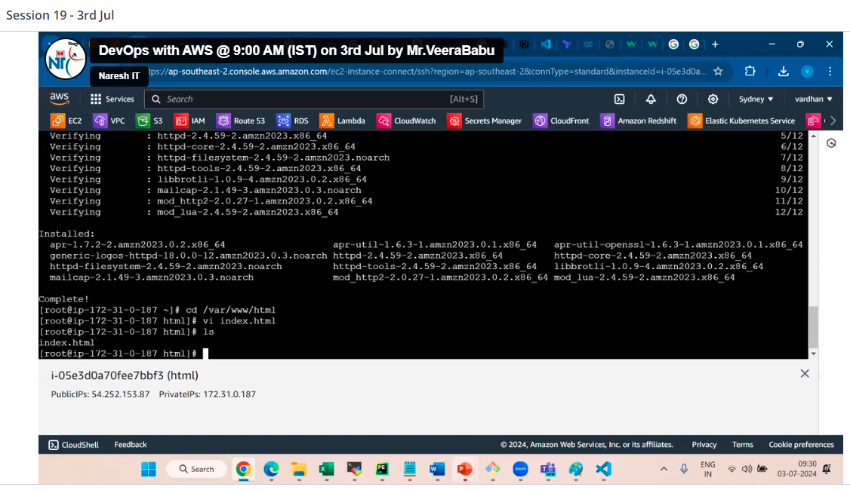

Systemctl start httpd to start the apache web server

Systemctl status httpd to know the running status of apache web server

Systemctl stop httpd to stop the apache web server

Systemctl enable httpd apache web server interact with main ec2 server (when server stops apache web server will stop and when server starts it will automatically start , we no need give command to start apache web server)

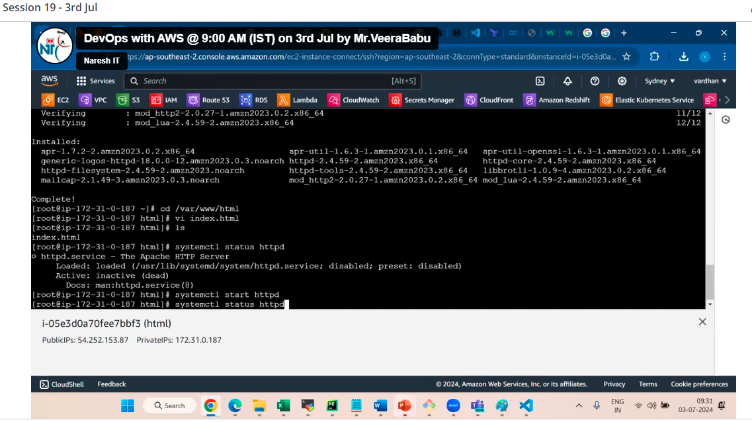

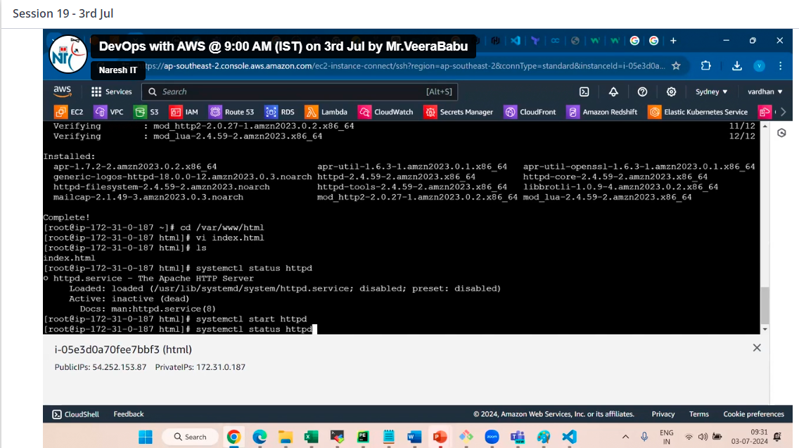

Now server is running

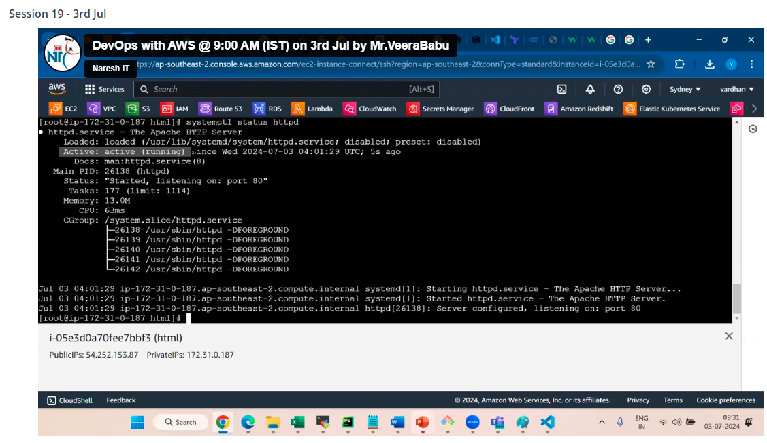

Then copy public IP down

Note this is possible because we are in public server

For private server we need to copy DNS from ELB

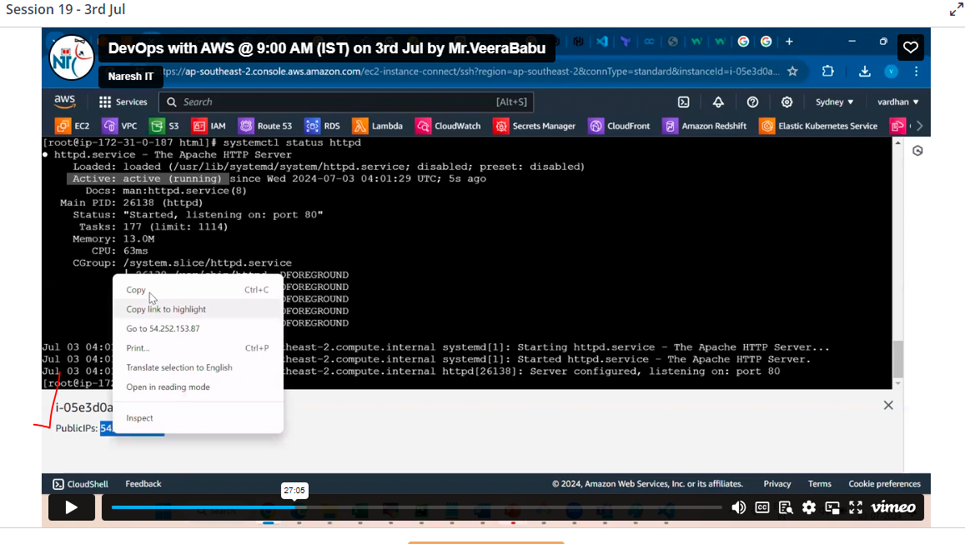

Paste in chrome we can see result

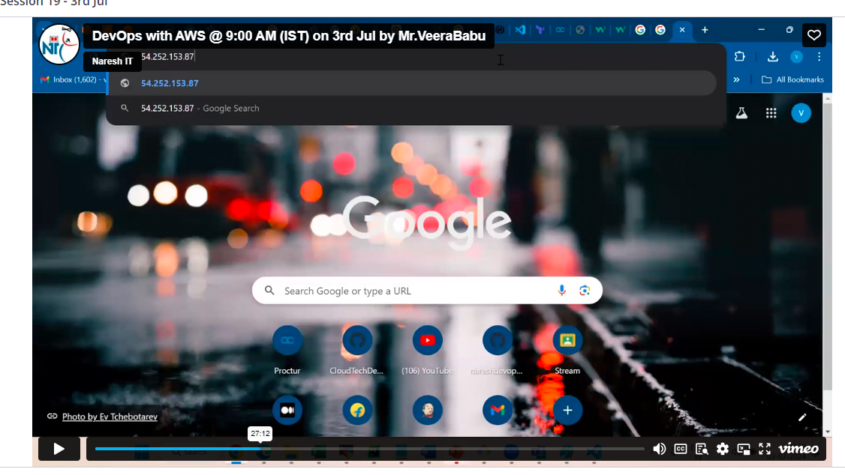

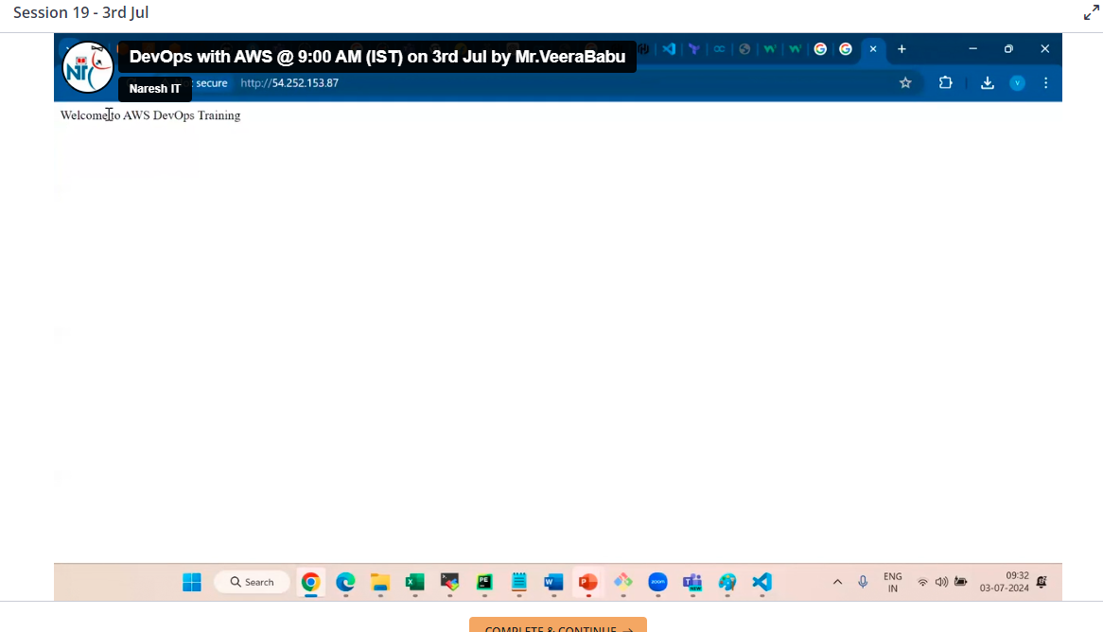

To change again vi index.html to write any thing

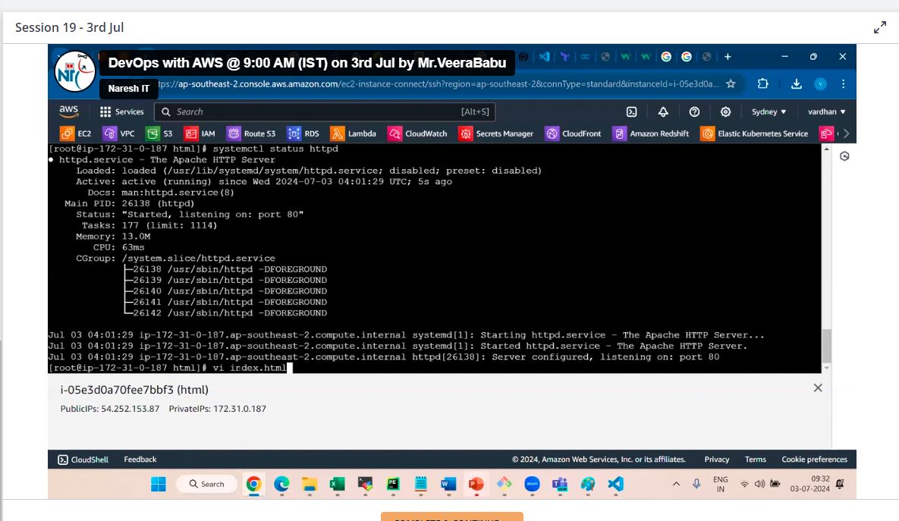

D for delete

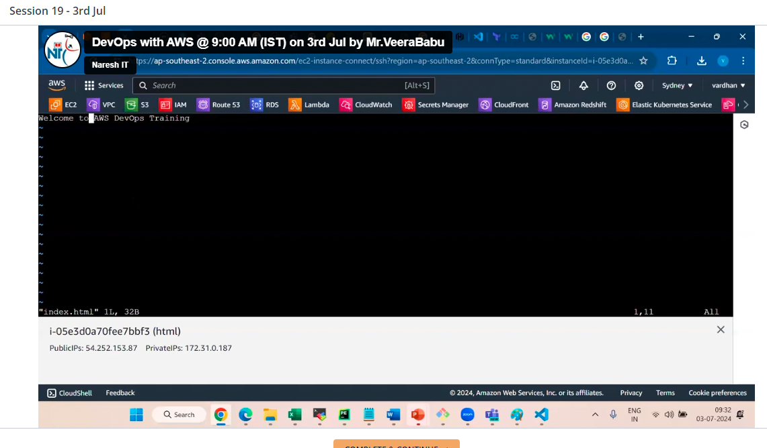

Copy and paste html basic code

:wq! To save content

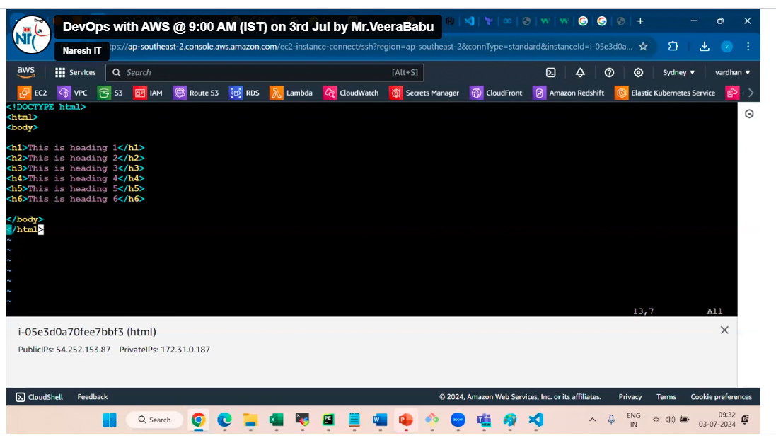

Now you can see the result

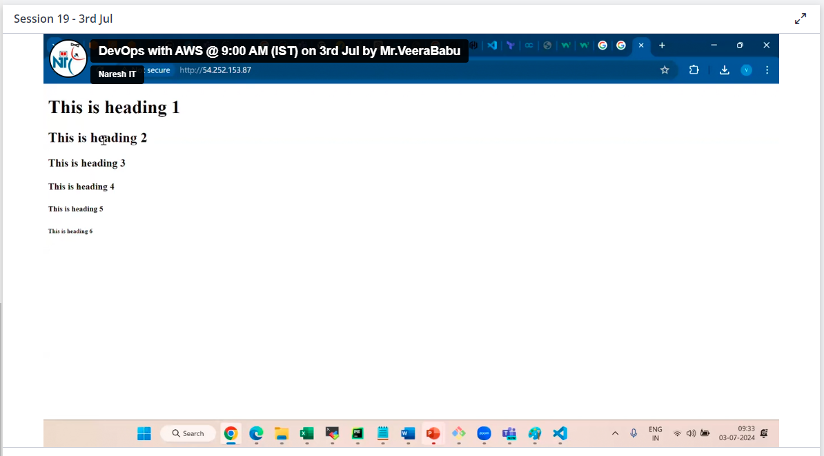

TG works under VPC level

ELB should be in public subnet only

Mapping is important in ELB

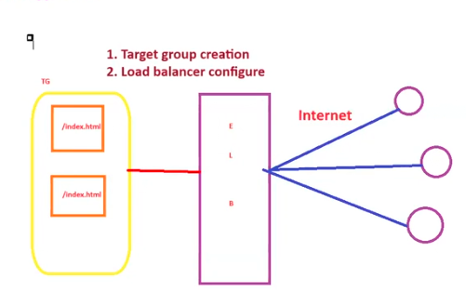

To create ALB no instance will be required, it requires 2 subnets in different AZ’s